Web Development (Introduction) & WEDE5020
Website project proposal
Part 1 Section 2 of 2:
Nonkululeko Sibiya
ST No. 10502108
Group 01
DNM0601
Diploma In Network Management
Due 08 August 2026
Lecturer: C. Nukeri

Contents
Content Research and Chosen organisation: KreatedbyKeora 3
Content Research and sourcing 3
Website Structure and planning 3
Website content Information 6
Homepage (index.html). 6
About Us (about.html) 7
Service & Pricing 8
Book / Enquiry 9
Contact page (contact.html) 10
Art_Work (art_work.html) 10

GitHub Link:

https://github.com/Nkuwed/WEDE-kbk-main.git

Content Research and Chosen organisation: KreatedbyKeora

Content Research and sourcing
Organisation’s Website
The business does not have an existing website.
Social Media
The business has a TikTok and an Instagram page. The pages are active and are ran by the business owner.
Public domain and creative commons resources and original content
All images were taken by the business owner using her personal device.

Website Structure and planning
4.1 The Sitemap.
- Hierarchical Representation of the website structure:
- Homepage (index.html)
- About Us (about.html)
- Services (services.html)
- Enquiry/Book Now (enquiry.html)
  - Booking polices (deposits, late fee, cancellations)
- Contact (contact.html)
- Art_work(art_work.html)

4.2 The file and folder structure
KreatedbyKeora /
Index.html
about.html
services.html
enquiry.html
contact.html
art_work.html
css/
  - style.css
js/
  - main.js (nav, mobile nav)
  - a form validates js (the booking form validation)
images/
hero/ (the owner’s photo/logo)
portfolio (nail art content that will be sourced from the business’ Instagram and TikTok)
icons/
README.md

The HTML structure and content plan of the website.
- index.html
  - <header> Logo/owner image and a sticky, <nav> (mobile, thumb-friendly button</nav> </header>
  - Hero <section> brief introduction with the ‘Book Now’ CTA button to enquiry.html
  - <footer> The WhatsApp & Call number and the social media links.
- aboutus.html
  - <main>- Keora’s story and the journey into nail artistry
  - Business background, the challenges and studio philosophy as a separate <sections>
- Services.html
  - Service menu as a semantic <table> or list; gel, acrylic, simple and the dramatic nail art
  - State the pricing per treatment and requests
  - Portfolio with the images that will be taken from the social media platforms, with descriptive alt text
  - CTA linking to the enquiry.html
- enquiry.html
  - Booking <form>: preferred date, service, optional reference image upload.
  - Client-side JS validation (required fields, valid phone number and email)
  - Booking Policies section: The deposit, late fee, last-minute cancellation terms.
  - Short POPIA-style privacy note that will be above the submit button.
- Contact.html
  - The WhatsApp click-to-chat button and call number
  - Social Media Links (Instagram and TikTok)
  - Studio Address embedded via Google Map.
- Art_work
  - Shows that nail art the Ms Keora has already completed.

Website content Information
GitHub Link:
https://github.com/Nkuwed/WEDE-kbk-main.git

Homepage (index.html).

Header
Navigation: Home; About us; Services; Book/Enquiries; Contact; Art_Work
Slogan: Every set, hand-finished with intention.
Location: Kibler Park · Johannesburg South

Nail artistry, krafted by Keora.
Gel-X extensions, dramatic nail art and everyday manicures — booked in a few taps instead of a comment section.

Featured Nail Art
Design 01
Design 02
Studio Mark
Design

Popular this month
Gel-X Charm Set
Gold Jewel Set
Pink Ombre

Built on social proof
A loyal client base grown through TikTok & Instagram since 2023.

Book with confidence
Clear pricing, deposits and policies — no more DM back-and-forth

Logo: KreatedByKeora
Text: Nail artistry studio based in Kibler Park, Johannesburg South. Bookings via website form or WhatsApp

Footer:
© Nonkululeko Sibiya ST10502108 2026 KreatedByKeora. All rights reserved.

Home; Service; Enquiry; Contact

About Us (about.html)

Header
Navigation: Home; About us; Services; Book/Enquiries; Contact; Art_Work
Meet the artist

Meet Keora
Nail technician based in Kibler Park, Johannesburg South — building a loyal client base since her social media launch in 2023.

Her journey
Keora's move into nail artistry began with a love of art and a want to keep exploring her creative side. Becoming a qualified nail technician gave her a canvas for that — and a new challenge to grow into with every set she creates.

Business background & challenges
KreatedByKeora is a real, independently operated studio, formed in early 2023. Keora built her client base almost entirely through TikTok and Instagram, taking bookings by direct message and comment section. As the following grew, that system started to show its limits: no centralised price list, no formal booking process, and low visibility to anyone outside her existing followers — which is exactly what this website sets out to fix.

Studio philosophy
Every appointment is treated as a small collaboration — quality and creativity first, at a price that keeps affordable, high-craft nail art accessible to every client who sits in the chair.

Mission
Creative, high-quality, affordable nail artistry — accessible to every client, while growing into a recognised professional brand in Johannesburg South.

Vision
To grow from a home/mobile-based studio into a go-to nail destination, and one day partner with major brands for seasonal promotional events.

Who it's for
Women aged 18 to 45 in and around Kibler Park and greater Johannesburg, looking for Gel-X extensions and dramatic nail art.

Featured
Glamour South Africa's local nail artist round-up, 2025.

Footer:
© Nonkululeko Sibiya ST10502108 2026 KreatedByKeora. All rights reserved.
Home; Service; Enquiry; Contact

Service & Pricing

Header
Navigation: Home; About us; Services; Book/Enquiries; Contact; Art_Work

Indicative pricing per treatment. Final price confirmed at booking based on nail length and design complexity
Classic Manicure
From R150
Shape, cuticle care and a clean polish finish
Gel-X Extensions
From R350
Lightweight, long-lasting length in your choice of shape.
Custom Nail Art
From R450
Hand-painted, jewelled or dramatic sculptural designs.
Gel Overlay
From R250
Strengthens and glosses your natural nail with gel.
Pedicure
From R200
Soak, exfoliation and polish for tired feet.
Add-on Design
From R50
A single accent nail or extra detail added to any set.
No services in this category yet — check back soon.
Footer:
© Nonkululeko Sibiya ST10502108 2026 KreatedByKeora. All rights reserved.
Home; Service; Enquiry; Contact

Book / Enquiry

Header
Navigation: Home; About us; Services; Book/Enquiries; Contact; Art_Work

Fill in your details and Keora will confirm your appointment by WhatsApp or email.

Full Name _ (Insert text) _Please enter your full name.
Phone Number_ (Insert text) _Please enter a valid South African phone number.
Email_ (Insert text) _Please enter a valid email address.
Preferred Service_ (Insert text) _Select a service -> Options
Classic Manicure — from R150
Gel-X Extensions — from R350
Custom Nail Art — from R450
Gel Overlay — from R250
Pedicure — from R200
Not sure yet
Please select a service.
Preferred Date _ (select the date if choice) _Please choose a preferred date.
Reference Image > _ (Select image of reference) _
Message / Details_ (Insert text) _Please add a short message so Keora knows what you'd like.
Deposit
A non-refundable deposit is required to confirm every booking and is deducted from your final price.
Late arrivals
Arrivals more than 15 minutes late may be asked to rebook, or a late fee may apply.
Cancellations
Cancellations made less than 24 hours before your appointment forfeit the deposit.
Your privacy: the details you share here are used only to confirm and manage your appointment, in line with POPIA. They are never sold or shared with third parties.
“Submit”
Thank you! Your enquiry has been received — Keora will confirm your booking by WhatsApp or email shortly.

Footer:
© Nonkululeko Sibiya ST10502108 2026 KreatedByKeora. All rights reserved.
Home; Service; Enquiry; Contact

Contact page (contact.html)
Text: Get in touch

*Embedded Google Map to the Studio Location*
Text:
- Kibler Park, Johannesburg South, Gauteng
- Mon – Sat: 09:00 – 17:00
- Bookings via the enquiry form or WhatsApp

Send a message
Name_ (Insert Text) _ Please enter your name.
Email _ (Insert Text) _ Please enter a valid email address.
Message _ (Insert Text) _ Please write a short message.
Send (Submit the form/message)
Text: Thanks — your message has been sent to the studio.
Nail artistry studio based in Kibler Park, Johannesburg South. Bookings via website form or WhatsApp.
Footer:
© Nonkululeko Sibiya ST10502108 2026 KreatedByKeora. All rights reserved.
Home; Service; Enquiry; Contact

Art_Work (art_work.html)
Text: Artwork
This page is for showcasing the nail artwork done by KreatedByKeora. It includes images of various nail designs, colours, and styles that have been created in the studio. The gallery is designed to inspire potential clients and showcase the creativity and skill of the nail artist.
Multiply images attached.

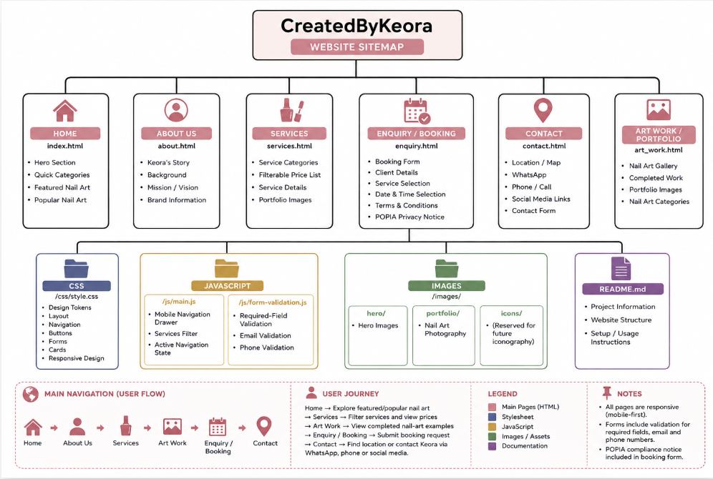
Figure 1Sitemap, created on Canva

Image Are used throughout the Website for KreatedbyKeora
